|  |  |
| --- | --- |
| **Computer Science 1** | **Lab 06D**  **Multi-Day Major Python Assignment** |
| **The Graphics Flowchart** | **80, 90 and 100 Point Versions** |
| **Assignment Purpose:**  The purpose of this program is to give students more experience in writing graphics programs, specifically the ability to display strings, while learning about flowcharts. | |

In the same way that an English teacher might require you to do an outline before you write an essay, a computer science teacher may require you to create a *flowchart* before you write a program. While you probably have seen flowcharts before, you may not know that official flowcharts have specific shapes with specific meanings. See the chart below:

|  |  |
| --- | --- |
| **Shape** | **Purpose in a Flowchart** |
|  | Ovals are used to mark the “beginning” and “ending” of a flowchart. |
|  | Rectangles are used for each individual step in a “process”.  This is the most common shape in a flowchart. |
|  | Arrows are used to indicate where you go next. |
|  | Parallelograms are used for “input” (acquiring information)  or “output” (dispensing information). |
|  | Diamonds indicate a “decision” which in the case of a flowchart  is a YES/NO question with 2 possible exit paths. |
|  | This is a “connector” or “portal” to some other location in the flowchart.  Given that lines are not supposed to cross, this is usually used when drawing a line from one shape to another would simply be too tedious. |

|  |  |
| --- | --- |
| **NOTE: Do not let your lines cross!**  If lines cross in this manner it can be confusing. |  |
| One possible solution it to put in a “hop” to indicate  that one line is going over the other. |  |
| Another solution is to use a “connector” or “portal”.  If you use one, it is called “A”.  If you have a second one, it is called “B” and so forth. |  |

Your mission on this assignment is to create a flowchart which explains – visually – the step-by-step process of how to do something. You decide what that “something” is, but keep in mind it must be school appropriate. You must also follow these requirements:

1. You must have exactly 1 “Begin” oval and 1 “End” oval.

2. You must have at least 5 process step rectangles.

3. You must have at least 1 input/output parallelogram.

4. You must have exactly 1 decision diamond.

5. The shapes must be connected with lines.

6. Using “connector/portal” circles is optional; however, lines may not cross.

7. Your entire flowchart must fit in the 1300 by 700 graphics window.

8. In addition to the “heading” at the top of the graphics window, you must also display something

to indicate what process is being performed by your flowchart.

9. You need to assign a separate color to each group of shapes. Choose either dark or light colors.

If you choose dark colors, use white text. If you choose light colors, use black text.

You are provided with the file shown below which gives you a mostly blank screen with a heading.

|  |  |
| --- | --- |
| **Lab 06D Student Version** | **Do not copy this file, which is provided.** |
| **1 # Lab06Dst.py  2 # "The Graphics Flowchart"  3 # This is the student, starting version of Lab 06D.  4   5   6 from Graphics import *  7   8 beginGrfx(1300,700)  9  10 # Substitute your own name here. 11 drawHeading("John Smith","6D") 12  13  14  15  16  17  18  19  20 endGrfx() 21** | |

**80 Point Version Specifics**

For the 80-point version, you need to satisfy all of the requirements explained on page 2.

**90 Point Version Specifics**

For the 90-point version, you need to satisfy all of the requirements explained on page 2 and add either

arrow heads or a second decision diamond.

**100 Point Version Specifics**

For the 90-point version, you need to satisfy all of the requirements explained on page 2 and add both

arrow heads and a second decision diamond.

**80 Point Version Sample Output**

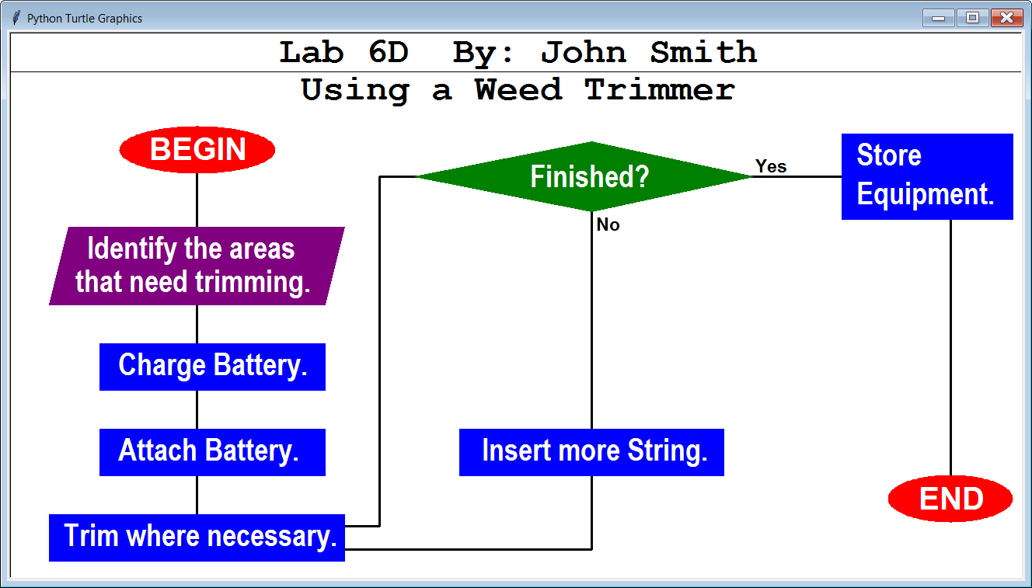

**100 Point Version Sample Output**

